**==========================================================**

**Windows forms Application**

**Library System  
(Group 2 Project)**

Prepared by class SE1626, Group 2

November 10, 2022

=====================================================================================

**Contents**

[Revision history](https://docs.google.com/document/d/1fFLykEiaydWHjiGMC-I_BH1oFkFXL5Au/edit?fbclid=IwAR2bgvTGbGHTK_VNEO0Z7urV-OIFFi7rEnGEYE6xPwN1RIC2KYk0tI9ElU8#heading=h.gjdgxs)

**1. Document description** **3**

**2. SRS overview** **3**

2.3. Use case diagram 3

2.4. Activity diagrams of use case scenarios 5

2.4.1. Activity diagram for use case “Login” 5

2.4.2. Activity diagram for use case “Manage the Book” 6

2.4.3. Activity diagram for use case “Borrow Book” 7

2.4.4. Activity diagram for use case “Manage the Borrowers” 7

2.4.5. Activity diagram for use case “Reservate Book” 9

2.4.4. Activity diagram for use case “Return Book” 10

**3. Data model** **11**

3.1. Entity Relationship Diagram 11

3.2. Class Diagram 12

3.1.1 Table name: Book 12

3.1.1. Table name: Copy 12

3.1.2. Table name: Borrower 12

3.1.3. Table name: Reservation 13

3.1.4. Table name: CirculatedCopy 13

**4.User Interface Model Design** **14**

4.1 Flow of forms 14

4.2 User interface model design 15

4.2.1. Screen “LoginGUI Form” 15

4.2.2. Screen “MainGUI Form” 15

4.2.3. Screen “MainGUI Form” 16

4.2.4. Screen “BookGUI Form” 17

4.2.5. Screen “BorrowGUI Form” 19

4.2.6. Screen “ReturnGUI Form” 20

4.2.7. Screen “ReservationGUI Form”21

4.2.8. Screen “HistoryGUI Form”22

# Document description

This document describes solution version 1.0 for Library System. It is divided into the following sections:

* In section 2 an overview of the Library System will be provided, including a list of system users, use cases, use case diagrams, and activity diagrams that describe the most important use case scenarios.
* In section 3 an E-R diagram and all tables of the Library System in detail will be presented.
* In section 4 all classes organized in the layers and their behaviors (sequence diagrams) for the most important use cases will be presented.
* In section 5 the most screen prototypes will be presented.

# SRS overview

**2.1. List of system librarian**

1. Management: The librarian manager Library System

**2.2. List of use cases**

1. Login/Logout

2. Reservate Book

3. Return Book

4. View History Reservate Book, return book

5. Borrow Book

6. Manage Book

## 2.3. Use case diagram

**2.3.1. Preliminary use case diagram**

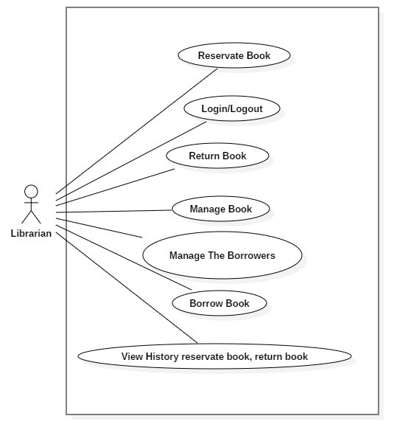

## 2.4. Activity diagrams of use case scenarios

### 2.4.1. Activity diagram for use case “Login”

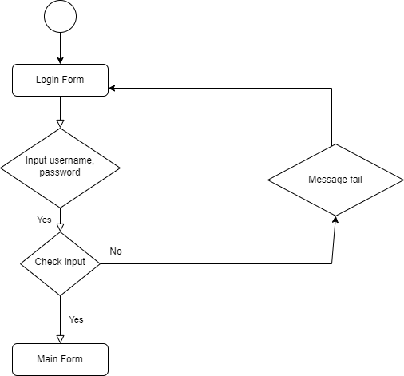

### 2.4.2. Activity diagram for use case “Manage the Book”

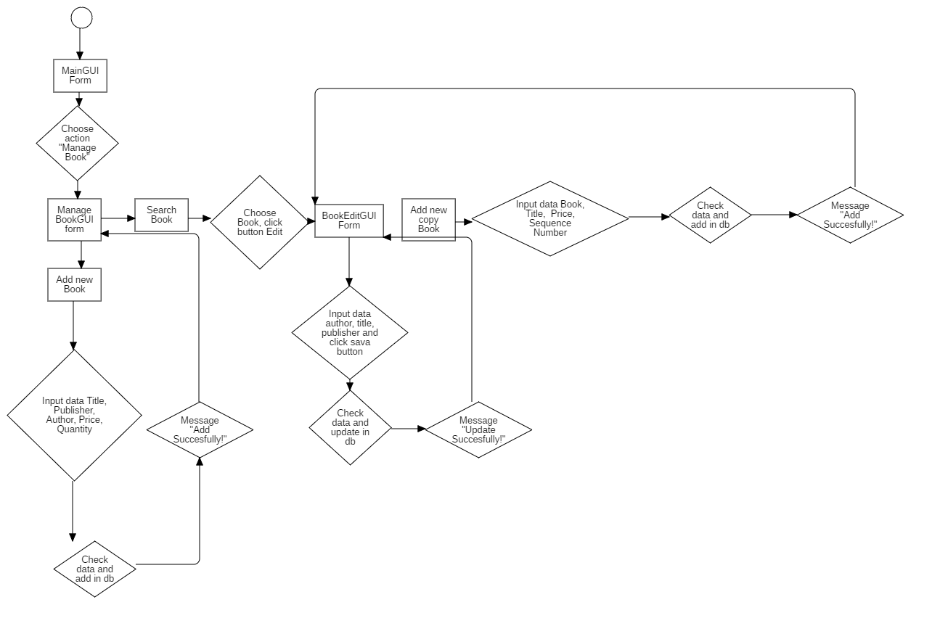

### 2.4.3. Activity diagram for use case “Borrow Book”

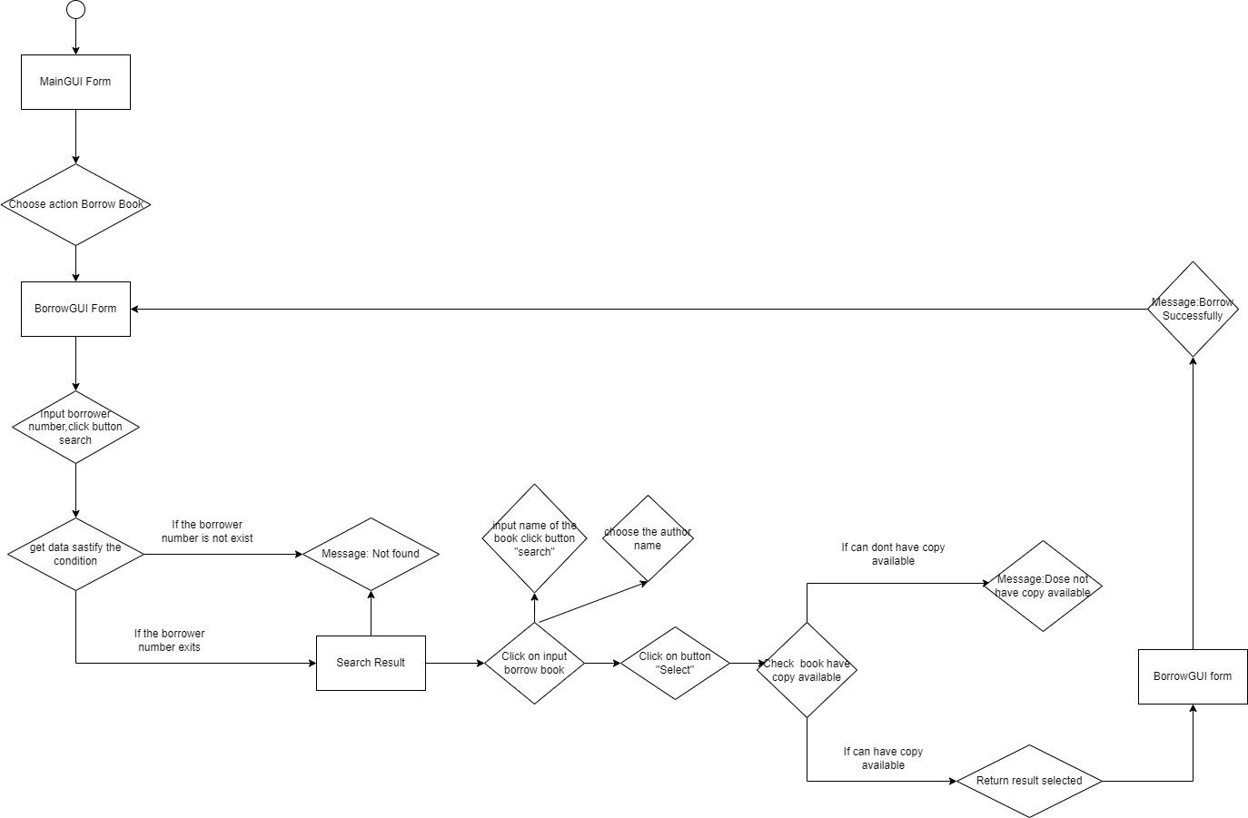

### 2.4.4. Activity diagram for use case “Manage the Borrowers”

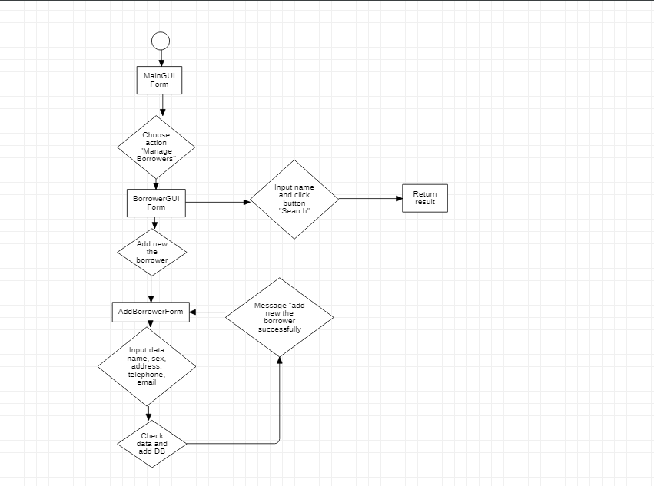

### 2.4.5. Activity diagram for use case “Reservate Book”

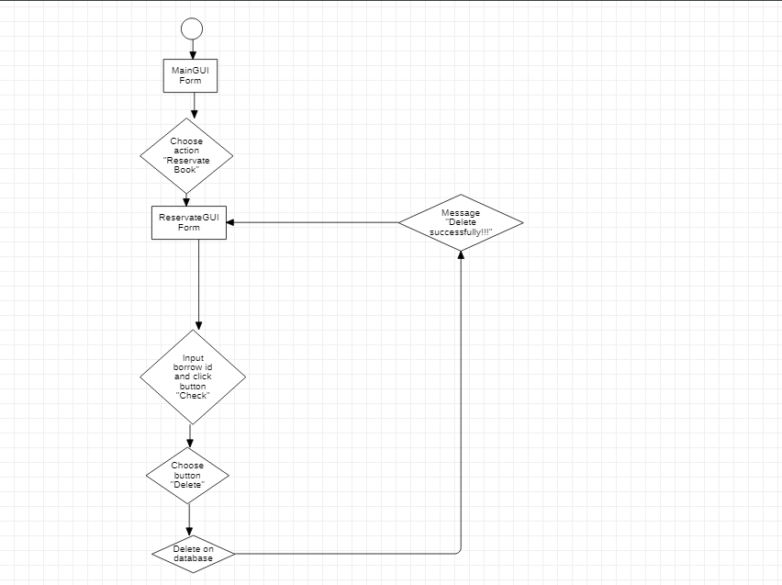

### 2.4.4. Activity diagram for use case “Return Book”

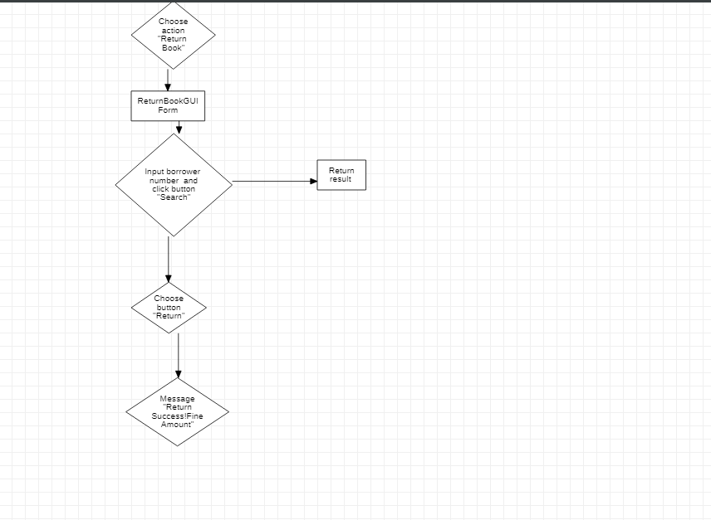

# Data model

## Entity Relationship Diagram

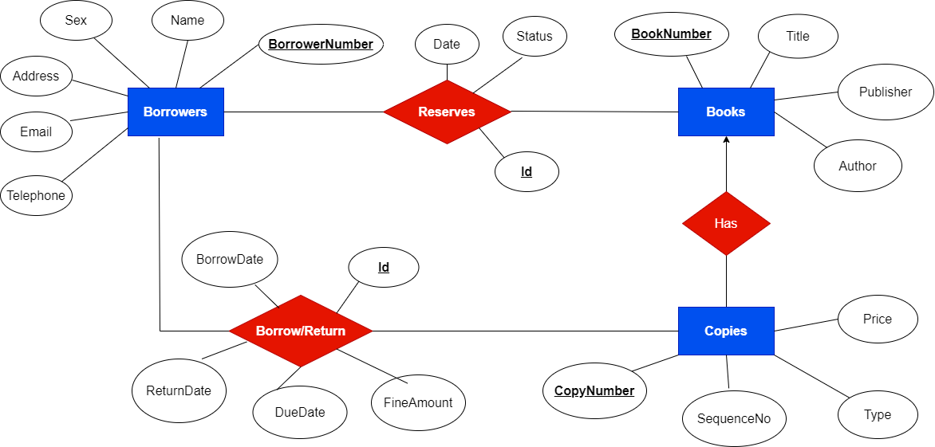

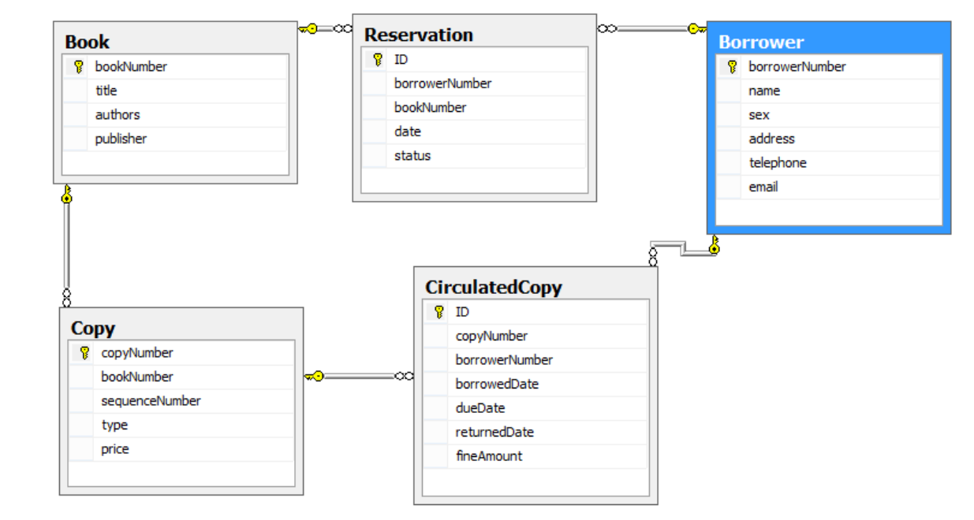

### 3.2 Class Diagram

### Table name: Book

| **Field name** | **Type** | **Size** | **Note** |
| --- | --- | --- | --- |
| bookNumber | Integer | 10 | Primary key |
| title | String | 40 | Not null |
| authors | Integer | 40 | Not null |
| publisher | Integer | 10 | Not null |

### Table name: Copy

| **Field name** | **Type** | **Size** | **Note** |
| --- | --- | --- | --- |
| copyNumber | Integer | 10 | Primary key |
| sequenceNumber | Integer | 10 | Not null |
| type | String | 100 | Not null |
| bookNumber | Integer | 10 | Foreign key, refers to Book table |

### Table name: Borrower

| **Field name** | **Type** | **Size** | **Note** |
| --- | --- | --- | --- |
| borrowerNumber | Integer | 10 | Primary key |
| name | String | 100 | Not null |
| sex | bit | 1 | Not null |
| address | String | 100 | Not null |
| telephone | String | 100 | Not null |
| email | String | 100 | Not null |

### 

### Table name: Reservation

| **Field name** | **Type** | **Size** | **Note** |
| --- | --- | --- | --- |
| ID | Integer | 10 | Primary key |
| date | DATE |  | Null |
| status | bit | 40 | Null |
| borrowerNumber | Integer | 10 | Foreign key, refers to Borrower table |
| bookNumber | Integer | 10 | Foreign key, refers to Book table |

### Table name: CirculatedCopy

| **Field name** | **Type** | **Size** | **Note** |
| --- | --- | --- | --- |
| ID | Integer | 10 | Primary key |
| copyNumber | Integer | 10 | Null |
| borrowedDate | DATE |  | Null |
| dueDate | DATE |  | Null |
| returnedDate | DATE |  | Null |
| fineAmount | Integer | 10 | Null |
| borrowerNumber | Integer | 10 | Foreign key, refers to Borrower table |

# 4.User Interface Model Design

# 4.1 Flow of forms

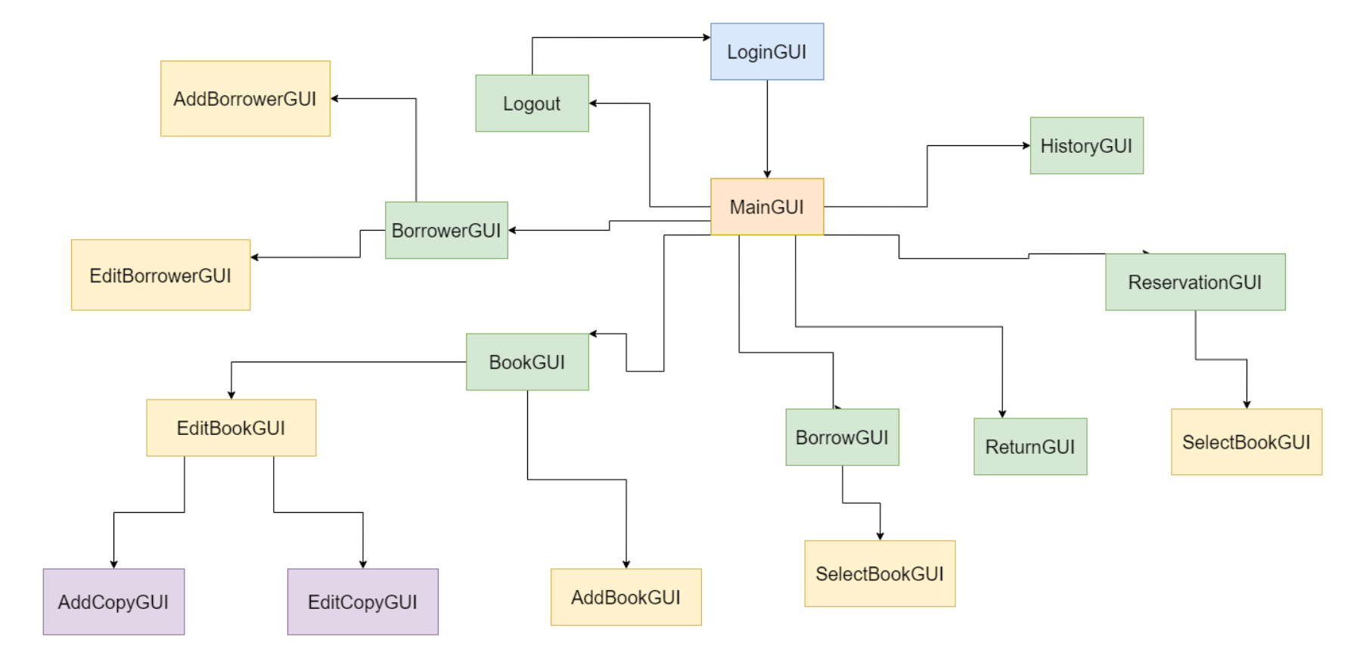

## 4.2 User interface model design

### 4.2.1. Screen “LoginGUI Form”

* Enter user name and password.
* Click the button “Login” and the system will check the account in the json file.
* If Username and password are correct the system will go to main form.

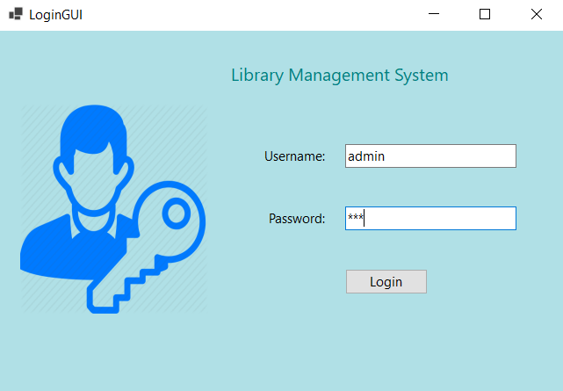   
*Login form mockup*

### 4.2.2. Screen “MainGUI Form”

* Display All Menu of the system in the taskbar. Introduction about the system.  
  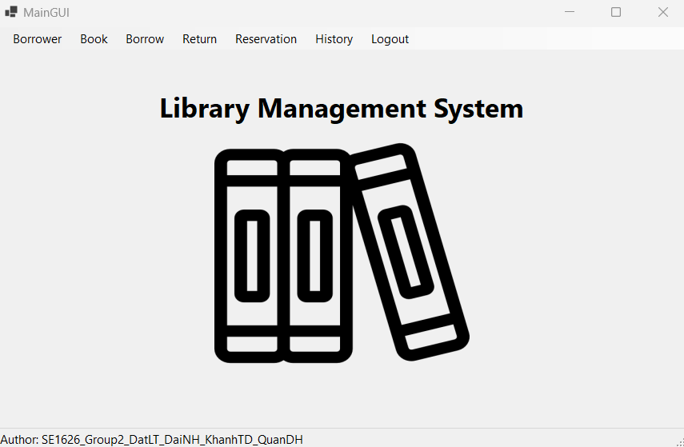  
   *Main form mockup*

### 4.2.3. Screen “BorrowerGUI Form”

* This form will display all borrowers in the system.

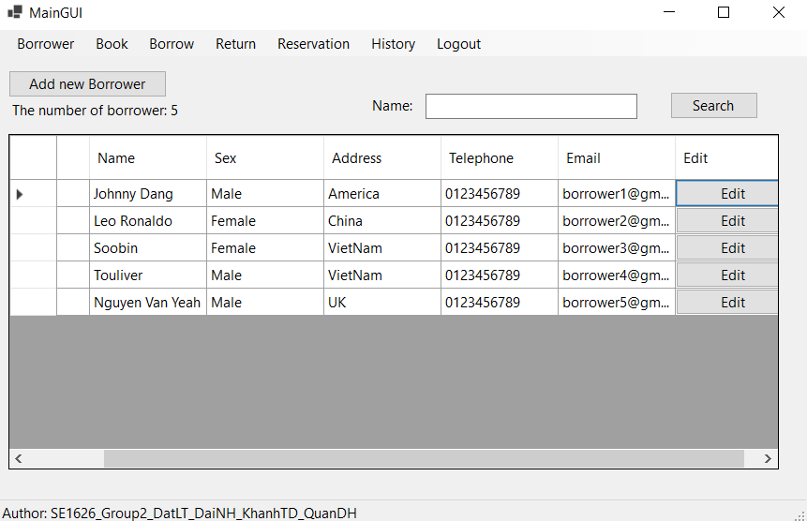

*Borrower form mockup*

* The librarian can Edit/Add new borrowers.

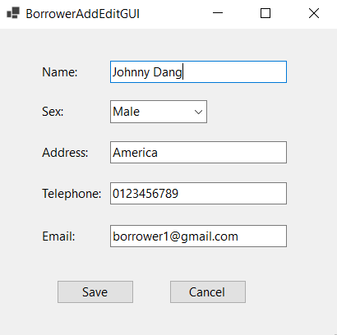

*BorrowerAddEdit form mockup*

### 4.2.4. Screen “BookGUI Form”

* View all books in the system

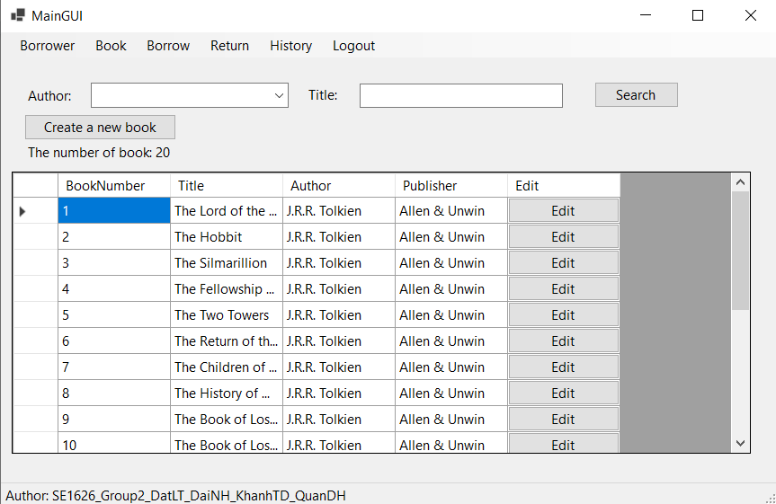  
*Book form mockup*

- Edit details of each book, books copied when click on edit button.

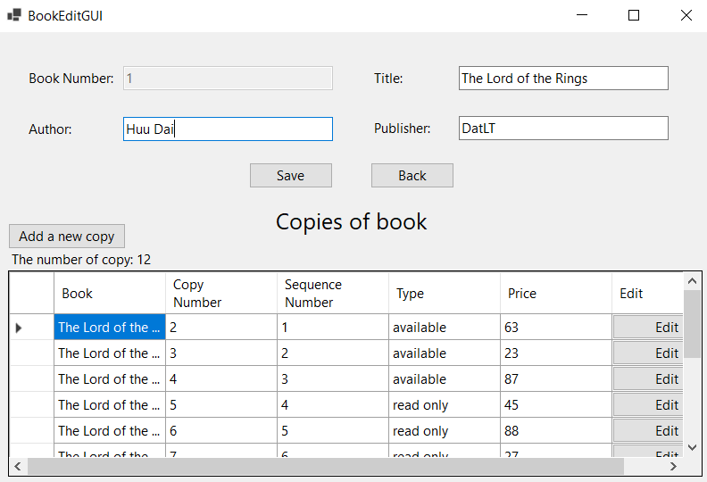

*Book Edit form mockup*

* Can Edit/Add a copy.

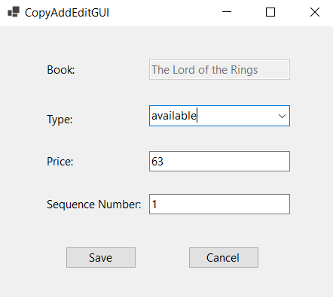

*CopyAddEdit form mockup*

* Can Add a new book or a new copy of the book.
* 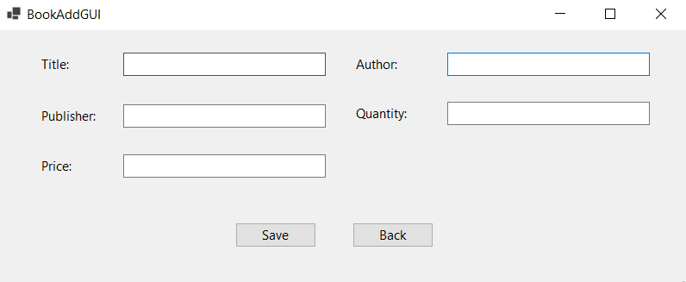

*Add book form mockup*

### 4.2.5. Screen “BorrowGUI Form”

* System will confirm the borrower and book details. If book status is available The librarian will then take the reserved copy and loan it out to the borrower.

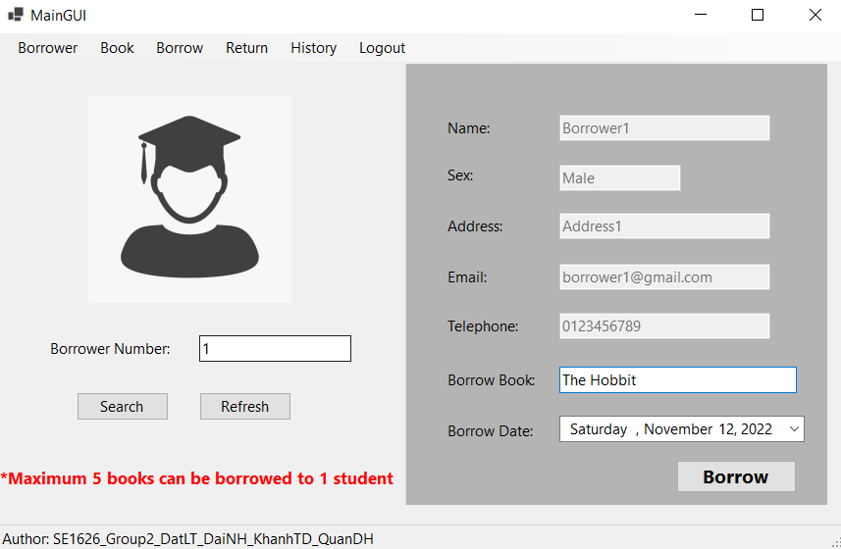

*Borrow form mockup*

* 1 Borrower can only take 5 books.
* A 2 week loan period is allowed per book
* If all available copies are out, the reservation will be created.

### 

### 4.2.6. Screen “ReturnGUI Form”

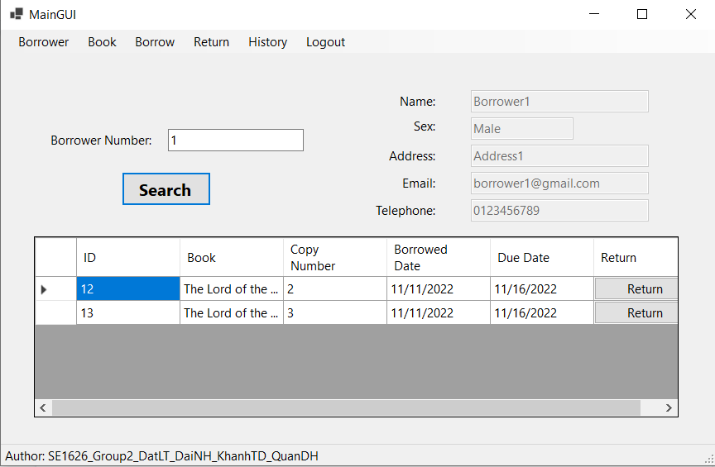

*Return form mockup*

* The librarian will check the book details. if the book is overdue, the borrower will have to pay a fine of 1 USD per day.
* The librarian will keep the copy if there is a reservation waiting for a copy and, a first come first served basis is used to assign to the borrower.

# 4.2.7. Screen “ReservationGUI Form”

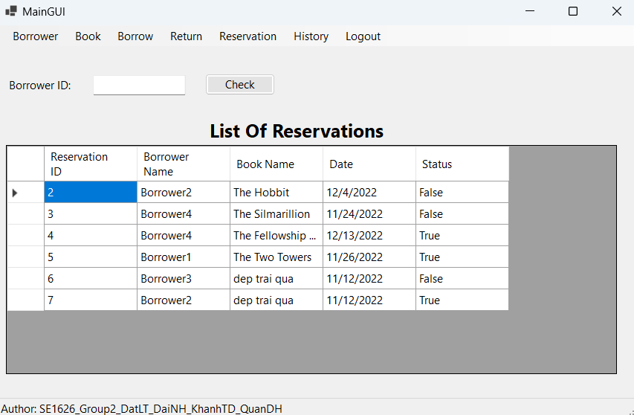

*Reservation form Mockup*

* The librarian will check the borrower, if the borrower reserved, he can not borrow more. If the borrower did not reserve, book select will show to create a reservation.
* If the other borrower returns a book that is reserved, the status of that reservation will change to false. The borrower making the reservation will borrow that book.

# 4.2.8. Screen “HistoryGUI Form”

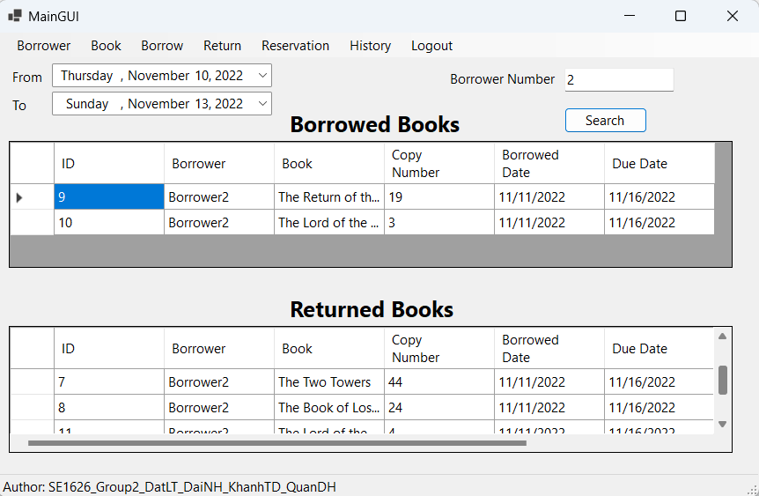

*History form mockup*

* The librarian can check history of borrowed and returned book